Classes are the basis of object-oriented programming; they define the structure and actions that should be performed on a specific instance of that class.
1.
Here’s a sample class definition that contains two methods:
class Course
def initialize(dept, number, name, professor)
@dept = dept
@number = number
@name = name
@professor = professor
end
def to_s
"Course Information: #@dept #@number - #@name [#@professor]"
end
def
self.find_all_students
...
end
end

In Ruby, everything is an object. In the real world, an object is anything you can see or
touch. In programming terms, it’s somewhat similar. An object is an actualized version of a class. Classes begin with the keyword class, followed by the class name. In Ruby, the class name must start with an uppercase letter.

The first method in the preceding Course class is called initialize, which is a special
Ruby method called a constructor. The constructor is the first thing called each time you
convert your class into a real Ruby object. The initialize method takes the parameters
that define the variables that are a part of the class: dept, number, name, and professor.

Let’s look at it in terms of building a house. Before you can begin construction, you need
to have some sort of blueprints that outline the layout of the house, the square footage,
and so on. Basically, this is what a class is: it’s a blueprint of your object. When you take the blueprints and actually build the house, you have created an object. The house is just like an object.

2. Another class explanation:
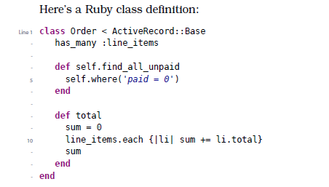
Class definitions start with the keyword class followed by the class name
(which must start with an uppercase letter). This Order class is defined to be
a subclass of the class Base within the ActiveRecord module.
Here has_many is a method that’s defined by Active Record. It’s called as the Order class is being defined. Normally these kinds of methods make assertions about the class, so in
this book we call them declarations.

Within a class body you can define class methods and instance methods.
Prefixing a method name with self.(as we do on line 4) makes it a class method
; it can be called on the class generally. In this case, we can make the following
call anywhere in our application:
to_collect = Order.find_all_unpaid

3.
Objects of a class hold their state in instance variables. These variables,
whose names all start with @, are available to all the instance methods of
a class. Each object gets its own set of instance variables.
Instance variables are not directly accessible outside the class. To make
them available, write methods that return their values:
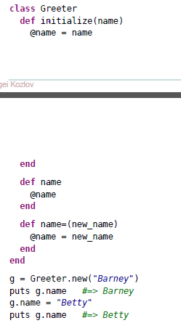

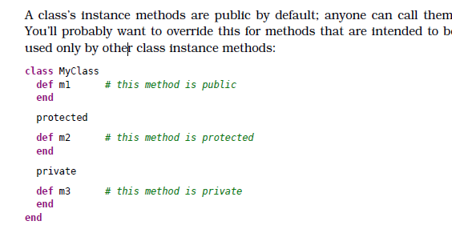

The private directive is the strictest; private methods can be called only from
within the same instance. Protected methods can be called both in the same
instance and by other instances of the same class and its subclasses.

